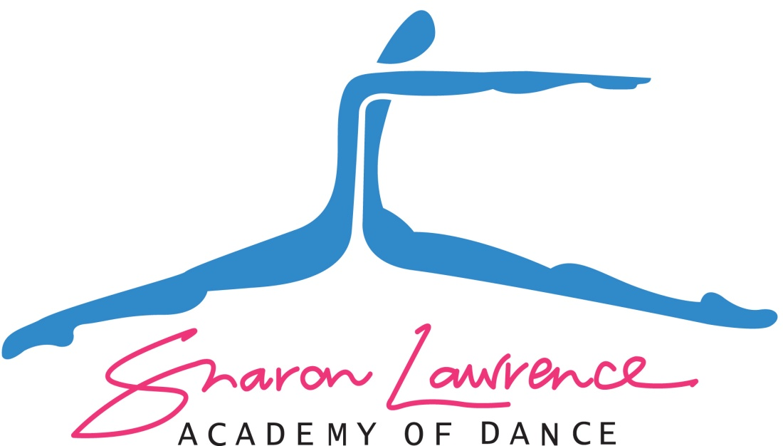

2022

Parent Information Handbook

Welcome to the Sharon Lawrence Academy of Dance

The objective of our school is to provide all round training in Classical Ballet, Tap, Jazz, Hip Hop, Acrobatics, Contemporary and Musical Theatre. In addition to the above, we also give students the opportunity for private vocal training. Some students will want to do classes for technique, fitness, confidence etc., and others will want to be more competitive and take our elite training program. This is entirely up to you. Please view our timetable at sldance.com.au under the heading of CLASSES so as you can discuss the appropriate training for your child.

Contents

- SLD TERM DATES & PUBLIC HOLIDAYS
- SHOWCASE DATE & VENUE:
- STUDIO MUSICAL THEATRE DISPLAY AND AWARDS NIGHT
- EXAM DATE & VENUE
- COMPETITONS
- DRESS CODE & UNIFORM
- CLOSED CLASSES/OPEN DAYS
- FEES (Including Bank details)
- LATE FEES
- LATE FOR CLASSES
- CONTACTING TEACHERS
- INJURIES
- ATTENDANCE
- LOST PROPERTY
- DANCE SCHOOL PROTOCOL
- PRIVATE LESSONS
- VOLUNTEERING
- FUNDRAISING/AMENITIES COST

SLD TERM DATES & PUBLIC HOLIDAYS
Term 1:
Monday 31st January to Saturday 9th April
Term 2:
Tuesday 26th April – Friday 24th June
Term 3:
Monday 11th July – Saturday 10th September (Showcase Perfomance)
Term 4:
Monday 3rd October – Saturday 10th December (School Display and Presentation Night)

SHOWCASE DATE & VENUE:
Our Showcase will be Saturday the 10th of September at the Alexander Theatre, Monash University Clayton. Times of our Showcase will be confirmed later in the year. There will be a rehearsal at the Theatre on the same day as the performance. There are no photo days to keep aside for the Showcase.

STUDIO MUSICAL THEATRE DISPLAY AND AWARDS NIGHT
Our Musical Theatre display and Awards night will be held at the SLD studios on Saturday 10th December at 5.30 pm for juniors (under 11years) and 7.00 pm for Inter/Seniors (over 11years).

EXAM DATE & VENUE
Exams will be held in March each year. Parents stay updated via. Email and the official closed Face Book page for more information closer to the event. More information will be sent home during the year with your child from their exam class teacher.
All grade exams are held in the studio.

COMPETITONS
If your child is selected for competition troupes, they will need to be available for troupes on the dates noted on our website front page information section. Selection for troupes is based on suitable ability, level of training and regular class attendance. Troupes students are expected to attend at least 90% of their classes to be eligible.
**Notable Competition Dates**
- Queen’s Birthday long weekend (Goodwill Competitions)
- First week of JULY School Holidays (Phoenix Competitions)

DRESS CODE & UNIFORM
Wearing of the full uniform for any student competing at the competitions or performing at our yearly Showcase and Studio Display is compulsory. This includes students sitting in the audience between performances. The SLD Uniform is identified by competition organisations and in most cases allow students free access to the audience areas and back stage without cost. Uniform consists of Academy Jacket with Logo (please email sldance@outlook.com) black Track pants or dance pants (from any department or dance store), and SLD t-shirt or singlet (available at the studio, please email sldance@outlook.com to order).

When attending classes, classical ballet classes will require mulberry pink leotards with pink tights, ballet shoes and hair is always to be in a classical bun. For theatrical lessons, students may wear jazz/tap gear such as dance pants, shorts, dance singlets, crop tops etc. in pink/black theme for girls and black & White for boys. No other colour scheme will be accepted in class. “Studio 7” in Moorabbin , Energetiks in Moorabbin and the “The Dancing Years” in Frankston have been briefed with all styles and colour themes we accept. Hair for theatrical classes must be tied and slicked back with hairspray or gel in a ponytail, braid, plait etc.
No nail polish, jewellery, tattoos, under pants hanging down under leotards are to be worn in classes.

SHORT PRACTISE SKIRTS SHOULD BE WORN FOR THE FOLLOWING CLASSES:

Pre-school Tap/Ballet – Girls
Saturday 8.30 am Tap classes
Wednesday 4.15 Ballet Recreational Class
Tuesday 4.15 8yrs&U Ballet Class

Short Mulberry or Pale Pink practise skirts available from Energetiks, The Dancing Years or Studio 7. Runners must be worn for hip hop classes. Ballet socks may be worn by younger under 8 students in the hot weather. Our studios are all fully air-conditioned.

CLOSED CLASSES/OPEN DAYS
All classes are closed to parents, which allows students to independently train without the distraction of an audience. Some group classes are open on the last week of term. Private lessons are able to be viewed on the last day of the term or at the discretion of the teacher.

FEES
Tax invoices for dance fees are issued on the first day of each month, or the 1st day of the month the term starts (depending on how you have chosen to pay your fees) . Invoices are due 7 days from the issue of the invoice. These will be sent to parents by email along with the monthly SLD newsletter. If you need to change your classes that you are enrolled in, either to add classes or to withdraw from classes, 5 working days due notice must be given ensuring we receive the changes or withdrawal from classes before our invoices are issued. Changing of invoices after they are issued throughout the term or month cannot be issued.

ENROLLMENT FORM
A yearly enrolment form is to be filled out by all parents of the school so as to update all details including email address, parent contact numbers, child’s allergies etc. Insurance/Amenities Fee must accompany enrolment otherwise enrolment is not complete and places in classes will not be held.

DANCE TUITION FEES:
Sharon Lawrence Academy of Dance
BSB: 063 581
ACC: 1026 1523

INSURANCE/AMENITIES ENROLMENT FEES:
SLD Enrolment Account
BSB: 033 065
ACC: 545 723

If your child is absent for a group lesson, where possible a make-up lesson will be arranged. ALL FEEES ARE DUE EVEN IF YOUR CHILD IS ABSENT, ILL, ON CAMP OR ON HOLIDAYS. Please email on sldance@outlook.com for suitable makeup lessons if your child has been absent.

If you are unable to attend your private lesson, 24 hours notice is needed so we will be able to fill that lesson. Full payment of the lesson will be due if 24 hours notice is not given. This applies to any private lessons including singing.
A fee structure leaflet is available in the foyer of the studio and sent to parents at the start of every year. Family breakdown of fees cannot be issued to parents by email, rather please study the fee structure so you can check your tax invoice each month or term.

LATE FEES
If a family falls too far behind with fees (that is, more than one month in arrears) the student, will unfortunately be unable to continue with training until such time as the fees have been paid.

LATE FOR CLASSES
Arriving late to classes on a regular basis cannot be accepted as this disrupts the class and also disadvantages the late student as most of the technical warm up at the start of each class is so important for their overall training and prevention of injury. If your child is late for their class, a verbal apology upon arrival to the class teacher is the correct protocol your child should use.

WHEN IS THE BEST TIME TO SPEAK TO THE TEACHERS?
After you have checked the website for any questions you may need answered, if you still have a query please email sldance@outlook.com. Before, during and after your child’s class is NOT the time to speak to any teachers in any of the studios at SLD. If you need to speak about anything to do with your child’s dance lessons etc. you will need to make an appointment to see the Principal or Manager by emailing the address above.

INJURIES
If your child is feeling slightly ill or has a minor injury, please send a note in with your child at the start of the class. Please inform the Principal or Manager in writing on the email above if your child has an injury they are seeing a Physio for or alternatively if your child is in the senior group, they should inform their teacher at the start of each class.

ATTENDANCE
If your child is going to be absent for class, please put a note on the SLD closed Facebook group. To join the site, find SLD Academy of Dance official site, ask to join and someone from Admin will approve you. This face book site is closed to the public but open to all staff, parents and senior students. There are a lot of news points and information that transpires on this site and it is a good way to keep up with what is going on here at SLD.
Competition and exam students are expected to attend almost all lessons if they are to be selected to participate in such events. If your child is going to be absent at camp etc. please notify me well in advance, by placing a note in the locked pay box in the foyer of the studio. Please always advise if your child is ill or cannot attend for any reason on the Facebook site above. Regular poor attendance will most definitely result in the withdrawal of the student from exams and troupes and/or solos, as it places unnecessary stress on other students and the teaching staff. ELITE AND TROUPE STUDENTS WILL NEED A MEDICAL CERTIFICATE IF THEY ARE ABSENT SICK.

LOST PROPERTY
Name all of your child’s clothing and shoes, this will help to have your property returned. The lost property box resides in the front foyer of the school. Any lost items can be also found by posting on the parent SLD site for all parents to check their child’s bag for any items not belonging to them.

DANCE SCHOOL PROTOCOL
It is expected that all students and parents conduct themselves in a courteous and gracious way when attending classes, display performances at the studio, competitions at various venues and our annual concerts at the theatre.

PRIVATE LESSONS
Private lessons are available to learn solo or duo work for competitions. There are also private lessons available to learn and strengthen technique in ballet, tap, jazz or singing. Please email sldance@outlook.com to enquire about private lessons. All students wanting to perform song and dance, song and tap and theatrical championships will need weekly private singing lessons. All classical solos are taught in a separate specialist lesson and all Championship lesson require additional or extra lessons than the normal lesson to upkeep their existing solos.

VOLUNTEERING
Parents who can spare time to fix props, paint or build props during the year for competitions and our annual concert, please drop a note in the pay box of the foyer to volunteer for the “Props Committee”. Our fundraising committee are always looking for new members to help out with Saturday lunch menu, end of term BBQ and other fundraising events had throughout the year.

FUNDRAISING/AMENITIES COST
At SLD, we have a $55 per family insurance/amenities fee due annually at enrolment to cover administration, amenities and insurance costs for your child/ren for that year. In addition to this, fundraising events happen throughout the year, and are optional with the exception of our annual chocolate drive for which we ask each family to participate to assist with costs of exam day extras, props for our Showcase and competitions etc. throughout the year.

